Дата: 27.09.2022 Клас: 7-Б

Предмет: Англійська мова

Тема: Соціальні мережі

Мета: формувати навички вживання нових лексичних одиниць; вивчити граматичне правило вживання слів «enough/ too»; удосконалювати навички аудіювання й усного мовлення з опорою на лексико-граматичні структури; розвивати мовну здогадку; виховувати доброзичливе ставлення до співрозмовника.

Вчитель: Глуговська Л.Г.

**Хід уроку**

***1.Greeting***Good afternoon, dear children! I’m glad to see you. Are you ready to start our lesson? Let’s start.

***2. Speaking/ warm up***

1. What is social networking?

2. Can you give any examples of social networking?

3. What are the most popular ones today?

4. Does the Internet help you with learning and doing your homework?

5. Have you joined any social networking site?

6. Do you post your photos?

7. How many hours a day do you spend on the computer?

***3. Reading***

Read the text and do the task.

WHAT TV DOES TO CHILDREN

Many years ago scientists and doctors began serious study of the influence of television on children and young people. And now they say that after parents television has the greatest influence on children today.

Of course, watching TV has its good and bad sides. From TV children get information about the world, they learn new words and begin to use them in their speech.

But TV also influences the development of a child in a negative way. When children spend all day in front of TV sets they cannot usually find time to read, to play games outside, to talk to their parents and friends.

Some teachers say that children who watch TV every day talk too much at school at the lessons. They can’t talk at home while watching TV and so they began to talk at school.

TV influences the creative abilities of pupils. Pupils who watch TV a lot can’t understand an easy story without pictures, tables and illustrations.

Television usually makes children passive. When a child watches TV he lives the lives of TV heroes, he travels with them, does everything with them. But he is not doing anything he is just sitting in an armchair and watching TV.

When a child watches TV, everything seems very easy to him. And real life begins to seem very easy. He cannot work hard, because watching TV does not need hard work.

**Say if the following statements true or false.**

1. TV has only positive influence.  
2. Children may learn everything from TV.  
3. While watching TV children have no time for anything else.  
4. Teachers believe that pupils talk too much at the lessons because of TV.  
5. TV improves the creative abilities of pupils.  
6. Children who watch TV a lot are very active.

***4. Grammar rule / Вивчення правил***

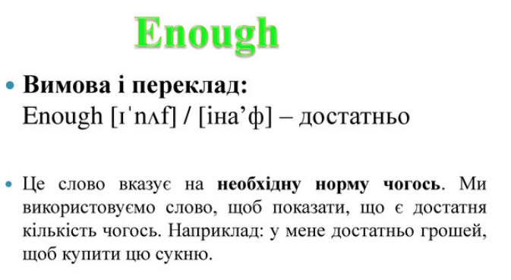

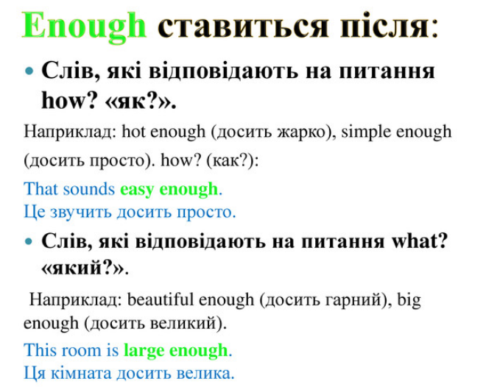

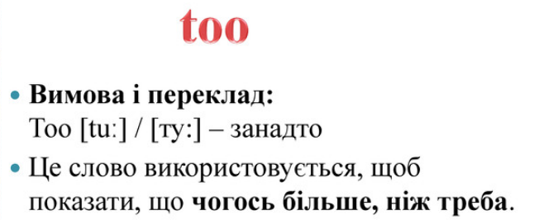

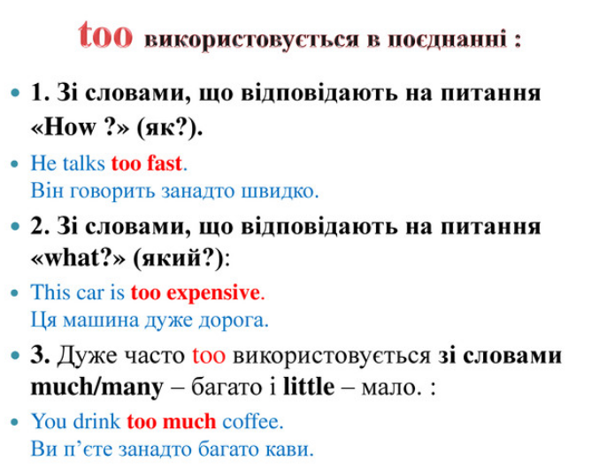

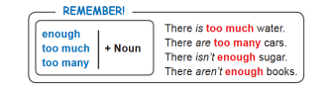

***5. Practice the rule***

*Доповніть речення вставляючи «too/enough»(усно)*



***6. Writing***

***Tuesday, the twenty seventh of September***

***Homework***

***Exercise 2 page 29***

*Доповніть речення використовуючи слова «enough/ too».*

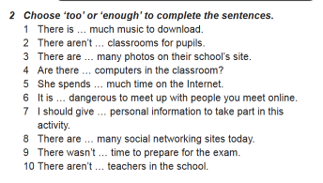

***7. Homework***

Домашнє завдання:

1. Опрацювати конспект, записати і вивчити правило *«enough/ too».*

2. Exercise 2 page 29 (письмово);

**Надіслати виконане завдання у Вайбер/телеграм (0964124047) – Людмила Григорівна або на Human.**